Session 14-2
1.Create a table called Orders with columns: order_id, user_id, order_date, and total_amount. Insert at least 7 sample rows representing different users and dates, similar to how food orders appear in Zomato or Swiggy.
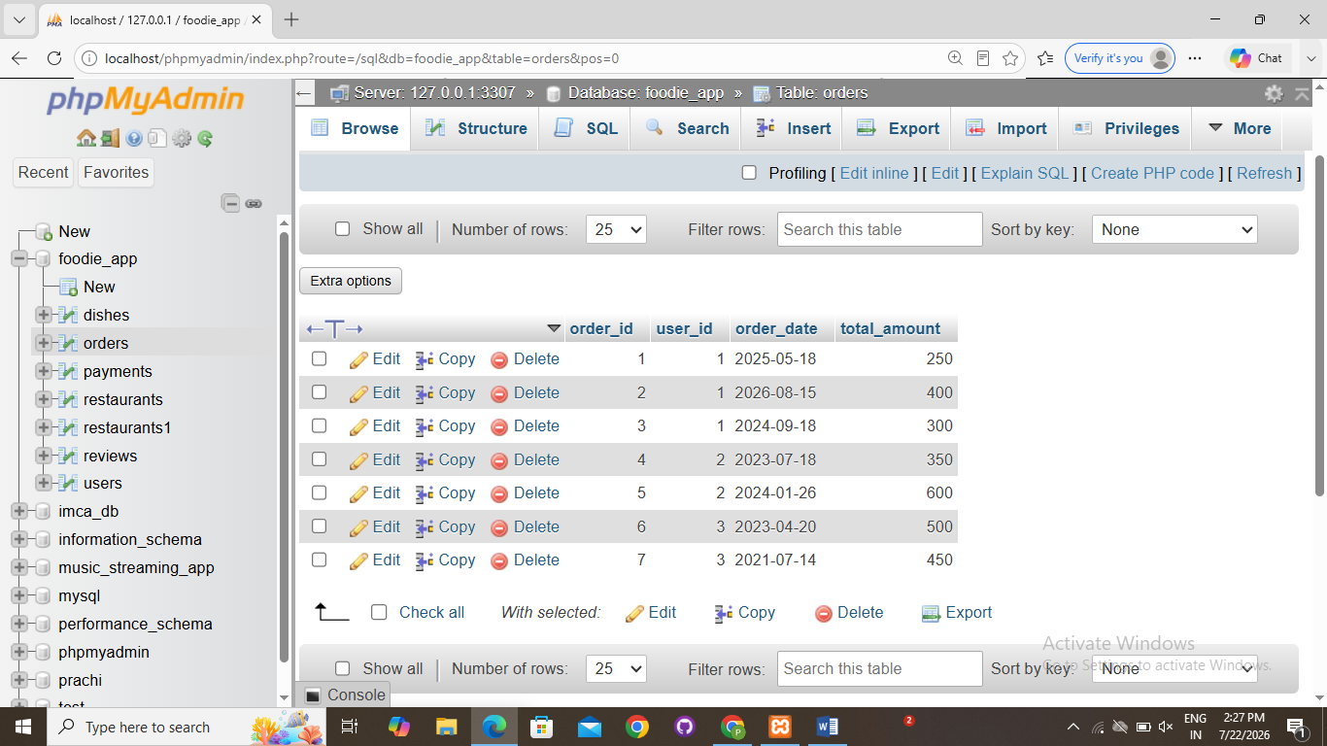
2.Write a SQL query using the LAG() function to show each user's order_id, order_date, and the total_amount of their previous order (if any), ordered by user and date.<br><br><em><strong>Hint:</strong> Use PARTITION BY user_id and ORDER BY order_date in your window function.</em>
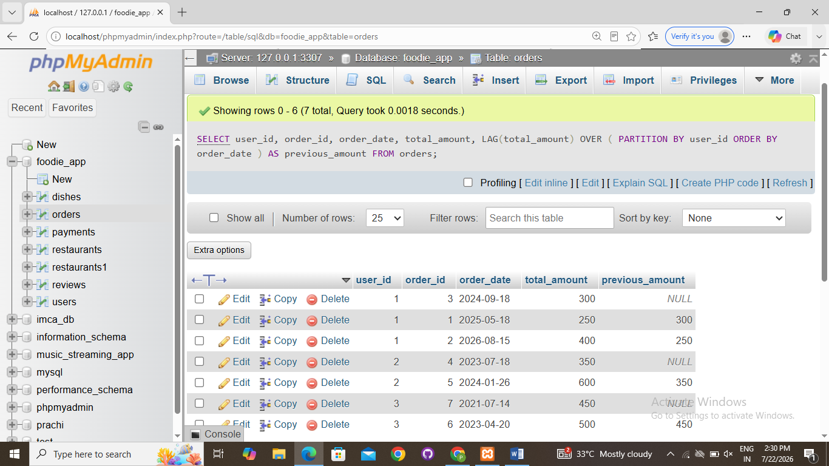
3.Using the same Orders table, write a SQL query with the LEAD() function to display each order_id, order_date, and the next order's total_amount for the same user.
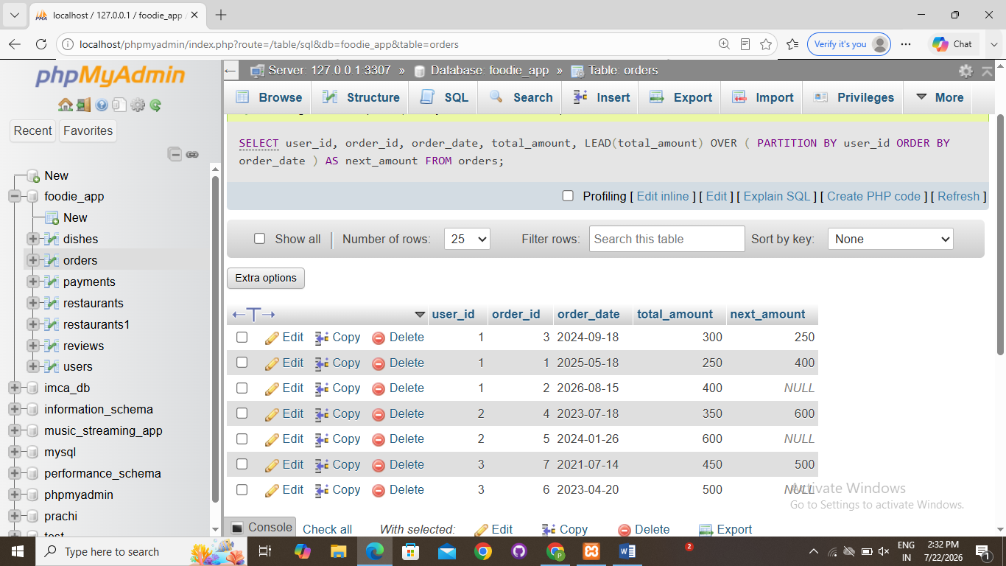
4.Write a SQL query to calculate the running total of total_amount for each user, showing order_id, order_date, total_amount, and a column running_total that accumulates the sum as you move through each user's orders.<br><br><em><strong>Hint:</strong> Use SUM(total_amount) OVER (PARTITION BY user_id ORDER BY order_date ROWS BETWEEN UNBOUNDED PRECEDING AND CURRENT ROW).</em>
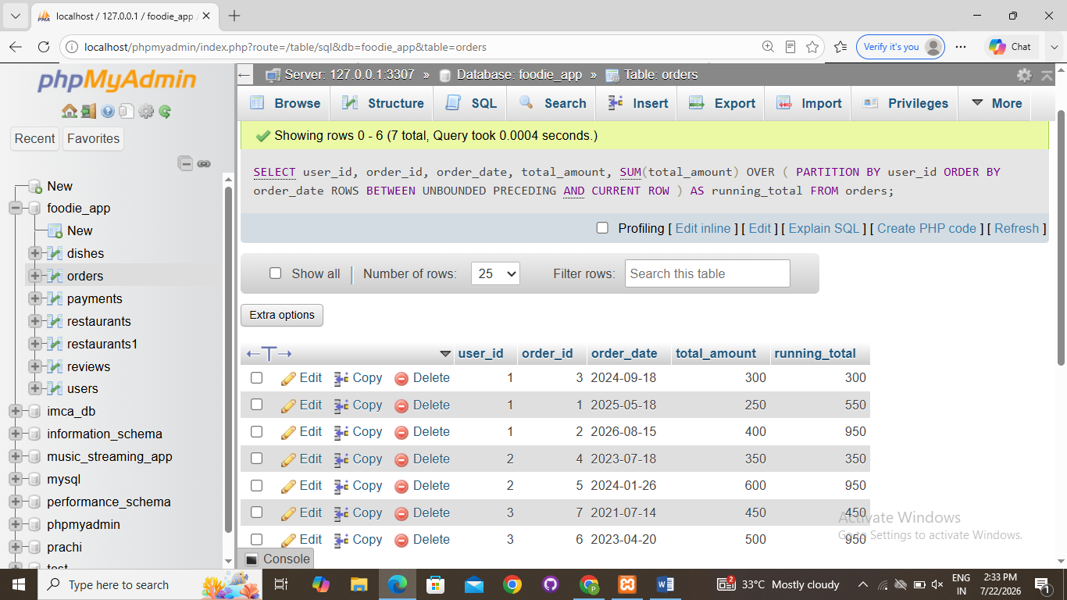
5.Write a SQL query to calculate a 3-order moving average of total_amount for each user, showing order_id, order_date, total_amount, and moving_avg columns.<br><br><em><strong>Constraint:</strong> Use SUM() OVER() with ROWS BETWEEN 2 PRECEDING AND CURRENT ROW to compute the moving average.</em
